Project 3.3 - Kubernetes Deployment with PV, ConfigMap, Secrets, and Services.

Task 1 - Prepare the Application Container
Use a containerized application image that requires configuration data and persistent storage.
Ensure that the application can store and retrieve data.
—In order to fulfil above requirements we will use PostgreSQL image [postgres:17] which is publicly available.

#cd ~/kubernetes-web-app
#mkdir -p project-3.3-postgres/k8s
#cd project-3.3-postgres/k8s

Task 2 - Create Persistent Volume
Define a Persistent Volume (PV) that provides storage resources for the application.
The volume should represent storage available within the Kubernetes cluster.

#vi pv.yaml
#kubectl apply -f pv.yaml
#kubectl get pv

Task 3 - Create Persistent Volume Claim
Create a Persistent Volume Claim (PVC) that requests storage from the persistent volume.
The application pods will use this claim to access storage.
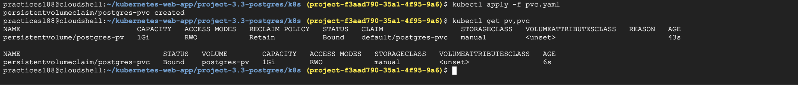

Task 4 - Create ConfigMap
Define a ConfigMap that stores application configuration values.
The application will use these values during runtime.
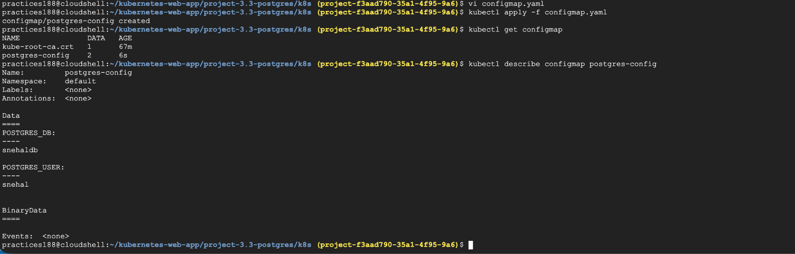

Task 5 - Create Kubernetes Secret
Create a Secret resource that stores sensitive information such as:
- ﻿﻿Database credentials
- ﻿﻿API keys
- ﻿﻿Authentication tokens
The application should access this information securely.

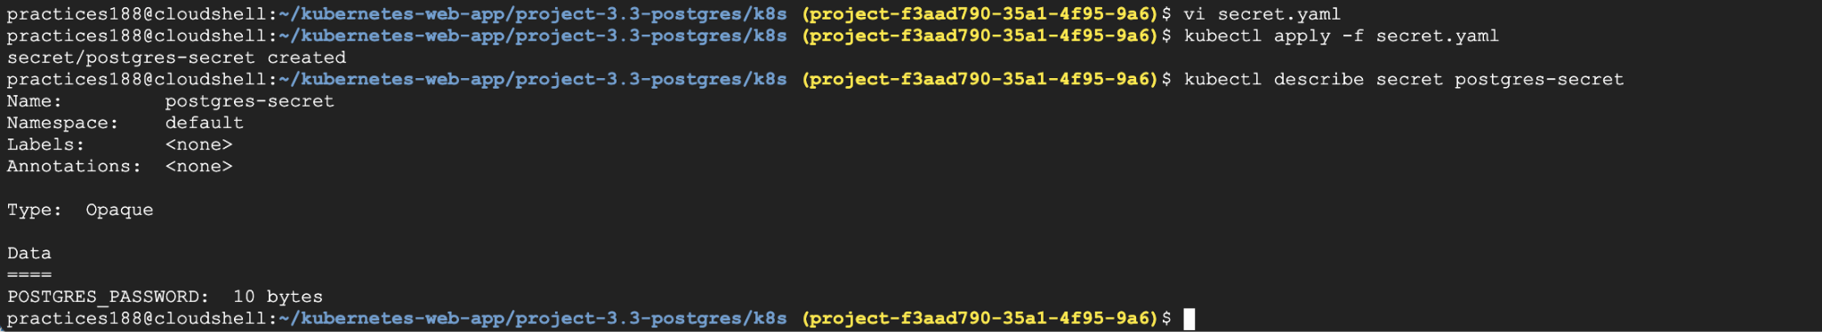

Task 6 - Deploy Application using Deployment Create a Deployment resource that manages application pods.
The deployment should:
- ﻿﻿Use the application container image
- ﻿﻿Mount the persistent storage
- ﻿﻿Load configuration from ConfigMap
- ﻿﻿Access credentials from Secrets

Requirement | Our implementation
Use application container image | postgres:17
Mount persistent storage | postgres-pvc → /var/lib/postgresql/data
Load configuration from ConfigMap | postgres-config
Access credentials from Secret | postgres-secret

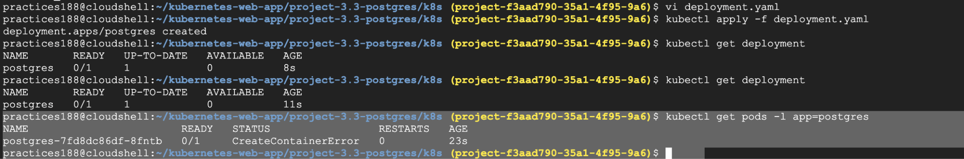

Error :
Troubleshooting:
#kubectl describe pod postgres-7fd8dc86df-8fntb
#kubectl logs postgres-7fd8dc86df-8fntb
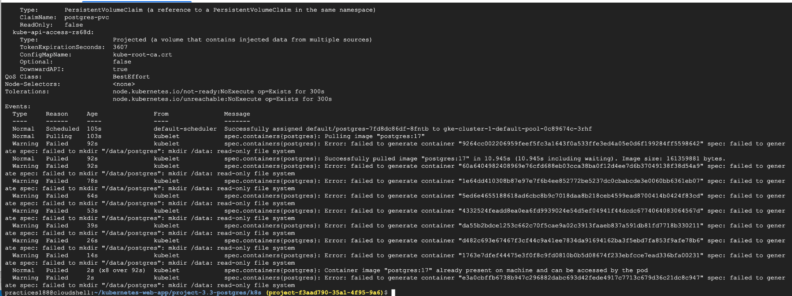

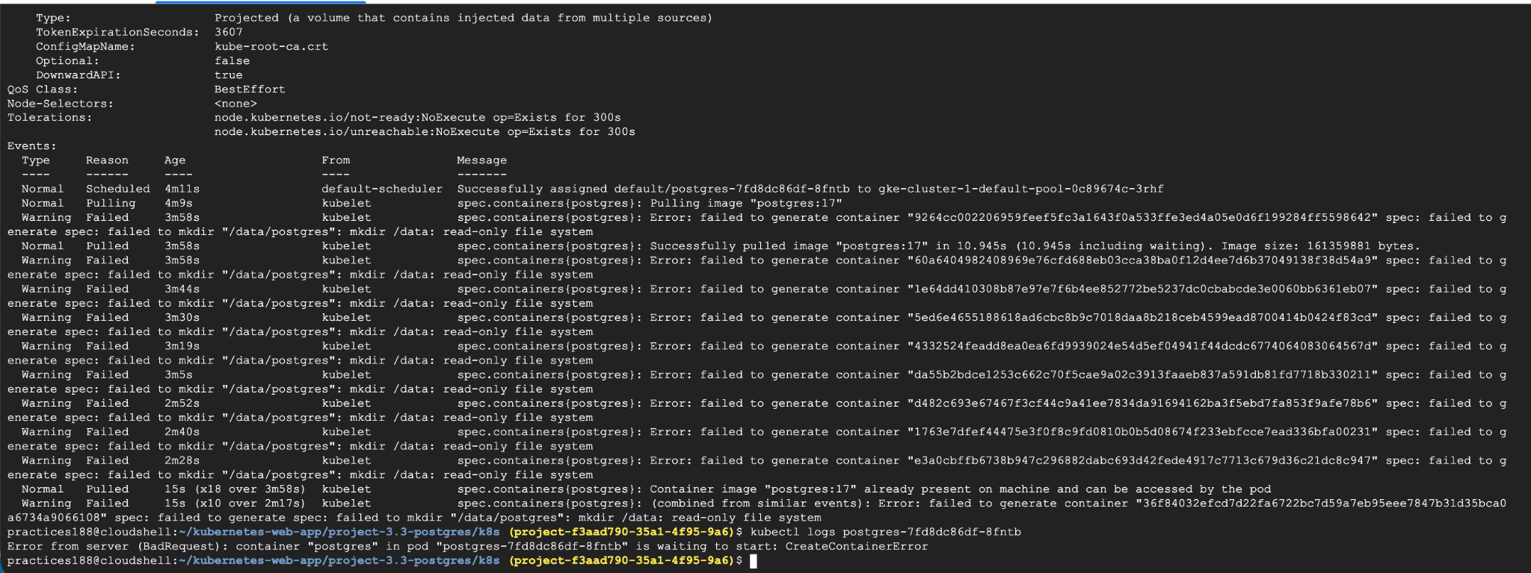
PV uses:
hostPath:
path: /data/postgres
But here cluster is GKE: gke-cluster-1-default-pool-0c89674c-3rhf
The GKE node's filesystem is read-only for creating that path, so Kubernetes fails before the PostgreSQL container can even start:
failed to mkdir "/data/postgres":
mkdir /data: read-only file system
correct fix for GKE : Since running this assignment on GKE, we should use a GKE-compatible storage class instead of hostPath.
PVC originally showed: STORAGECLASS: standard-rwo
That's actually the storage class we want to use on GKE.
We'll change the PV/PVC approach to use dynamic provisioning with GKE's standard-rwo StorageClass. However, there is an important Kubernetes point:
When using dynamic provisioning, you don't manually create the PV. The PVC requests storage, and GKE automatically creates the PV.

For this we have two options :
Option A — Recommended for this GKE assignment ⭐
Use the GKE standard-rwo StorageClass and let the PVC dynamically create the PV. This is the proper cloud-native approach, but technically the PV is automatically created rather than manually defined.
Option B — Keep a manually created PV
We can create a manually provisioned GCE Persistent Disk-backed PV, but this requires more GKE-specific configuration and is unnecessary complexity for this assignment.

So In order to fix this : check the Storageclass :
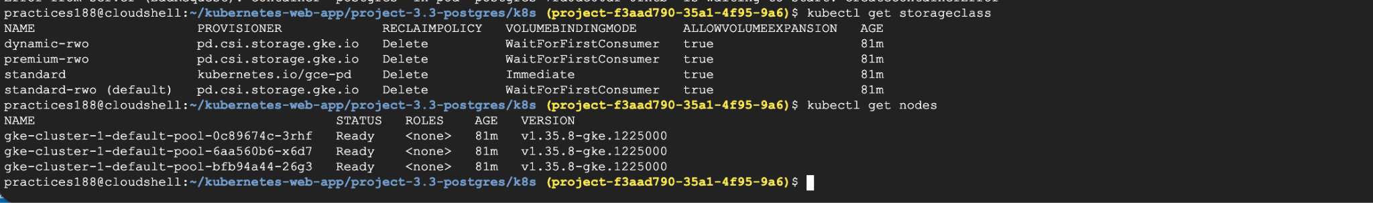

Now as we have a 3-node GKE cluster, and standard-rwo is the default GKE CSI StorageClass:
standard-rwo (default) pd.csi.storage.gke.io

previous hostPath PV is the problem because /data/postgres is node-local and isn't suitable here.

One important correction
Because of GKE, we should not manually create a hostPath PV. Instead, we'll use GKE's persistent-disk CSI provisioning.

For assignment, we'll still have:
PVC → dynamically provisioned PV → PostgreSQL Deployment.

This gives you real persistent storage on GKE.
Also, because PostgreSQL uses ReadWriteOnce, we'll keep:
replicas: 1

Now lets fix Task 2 and 3 Accordigly.
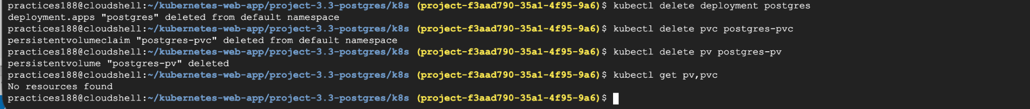

Create the GKE-compatible PVC
For GKE, we actually do not need a pv.yaml because the standard-rwo StorageClass will automatically provision the PV.

#kubectl delete deployment postgres
#kubectl delete pvc postgres-pvc
#kubectl delete pv postgres-pv
# kubectl get pv,pvc

Rename the old files:
#mv pv.yaml pv-hostpath.yaml
#mv pvc.yaml pvc-hostpath.yaml
Create the GKE-compatible PVC . For GKE, we actually do not need a pv.yaml because the standard-rwo StorageClass will automatically provision the PV.

Create the new pvc.yaml file for GKE-compatible PVC.
# ls
#vi pvc.yaml
#ls -l
# kubectl get pv,pvc
#kubectl apply -f pvc.yaml
#kubectl get pvc
#kubectl get storageclass standard-rwo

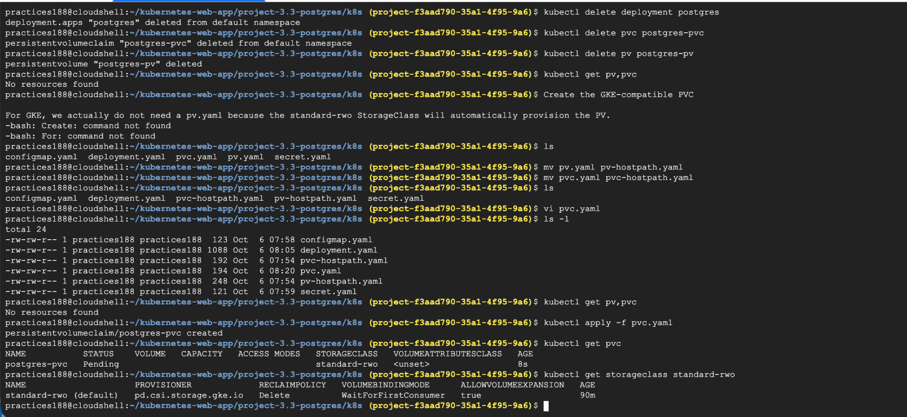

Your PVC is: pending
The reason is your GKE StorageClass:
standard-rwo
VOLUMEBINDINGMODE: WaitForFirstConsumer
GKE will provision the actual Persistent Disk when a Pod using this PVC is scheduled.

Now let’s continue with deployment:
I have renamed the old deployment file : onprem-deployment.yaml
#vi deployment.yaml
#kubectl apply -f deployment.yaml
#kubectl get pods -l app=postgres
#kubectl get pv,pvc

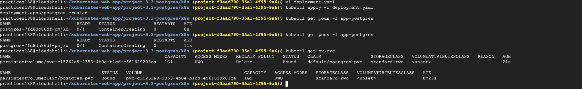

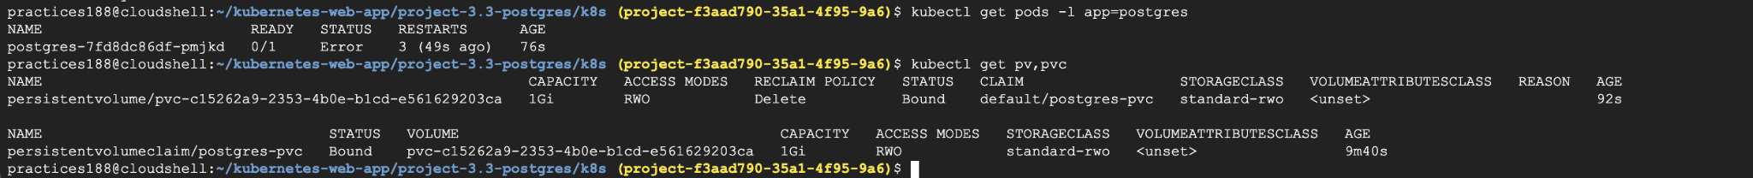

Error :
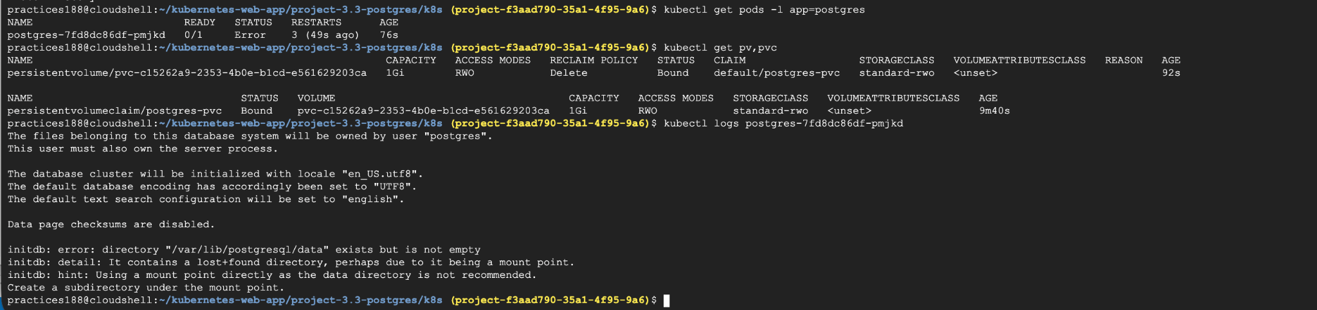
Troubleshooting :
#kubectl logs postgres-7fd8dc86df-pmjkd
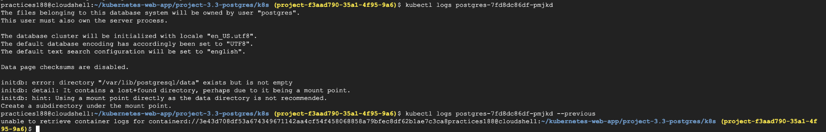

Why PostgreSQL is failing
The error says:
initdb: error: directory "/var/lib/postgresql/data" exists but is not empty
initdb: detail: It contains a lost+found directory

This happens because the GKE Persistent Disk filesystem creates a lost+found directory at the root of the mounted volume.
PostgreSQL wants its data directory to be empty.
The standard solution is to use a subdirectory inside the PVC, for example:
/var/lib/postgresql/data/pgdata
and tell PostgreSQL to use that directory through PGDATA.

Update deployment.yaml. Or else let’s rename this deployment for error showcase error-deployment.yaml and create another deployment.yaml

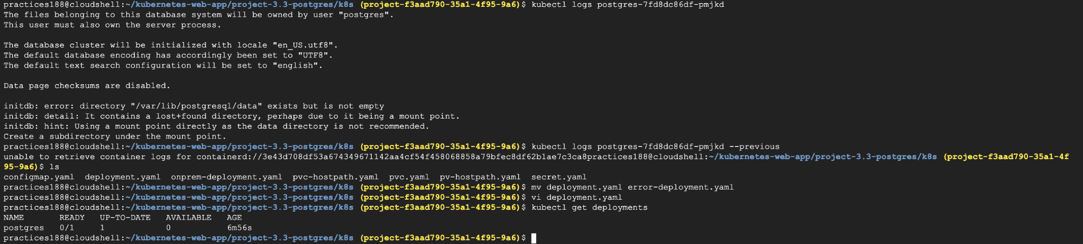

Delete the existing deployment and create the new one
#kubectl get deployments
#kubectl delete deployment postgres
#kubectl get deployments

#kubectl apply -f deployment.yaml
#kubectl get deployments
#kubectl get pods -l app=postgres -w
#kubectl get pv,pvc
#kubectl logs -l app=postgres
# kubectl get pods -l app=postgres
# kubectl get pv,pvc

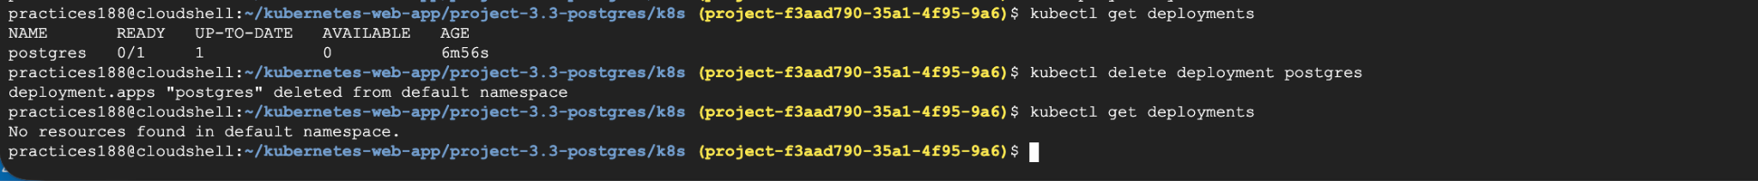

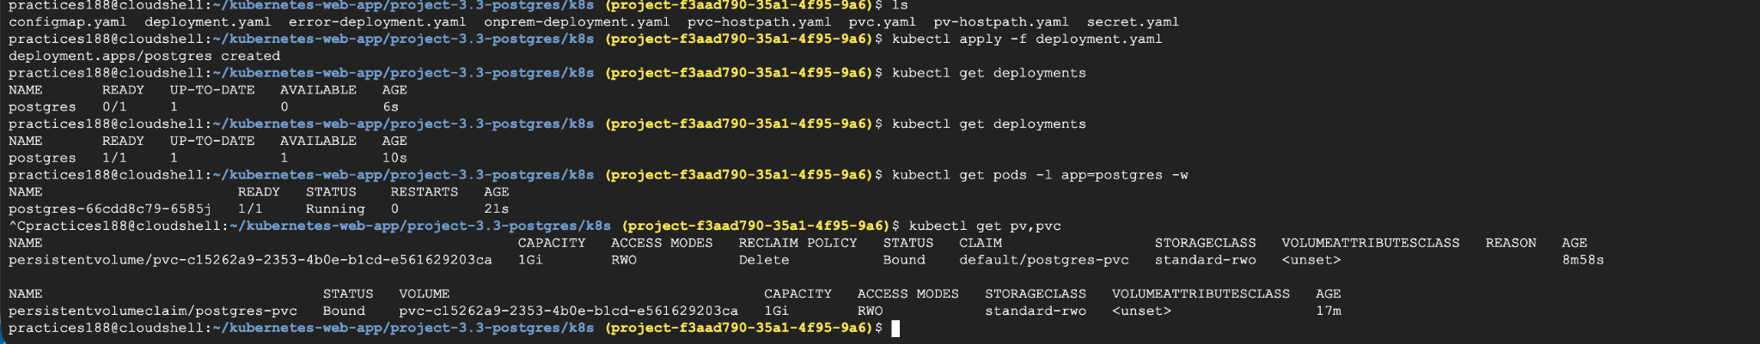

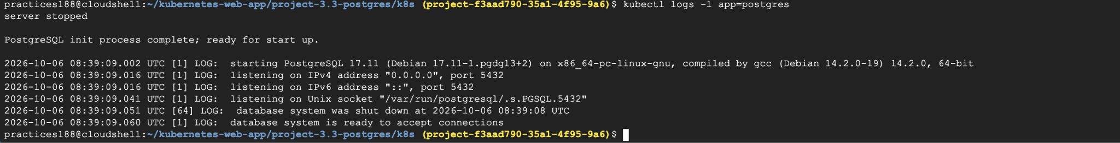

Task 7 - Expose Application using Service \ Create a Service resource to expose the deployed application.
The service will enable users or other applications to communicate with the pods.

#vi service.yaml
#kubectl apply -f service.yaml
# kubectl get service
#kubectl get endpoints postgres-service

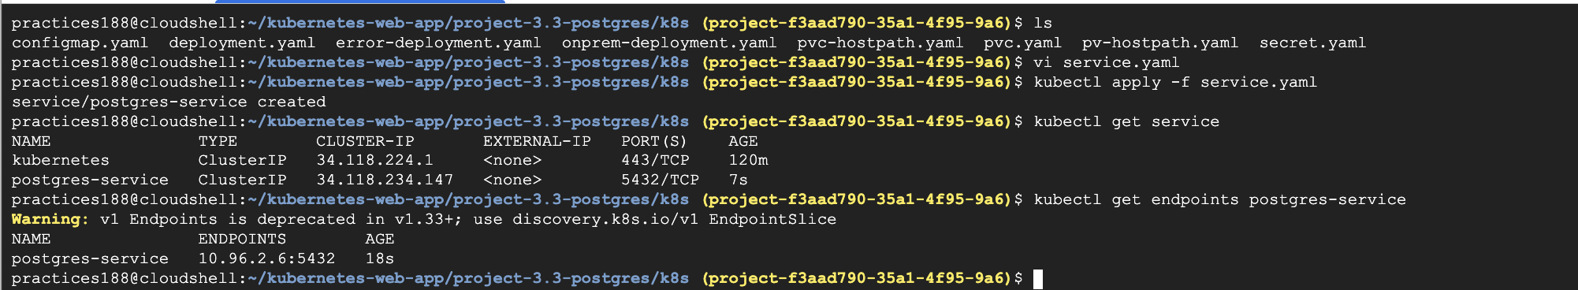

Since PostgreSQL is a database and only needs to be accessible inside the Kubernetes cluster, we'll create a ClusterIP Service on port 5432

Verification :
#kubectl get pods -l app=postgres
→First get the Pod name:
#kubectl exec -it postgres-66cdd8c79-6585j -- psql -U snehal -d snehaldb
—>Then connect to PostgreSQL inside the Pod

Once connected :
Now run:SELECT current_database();
\conninfo

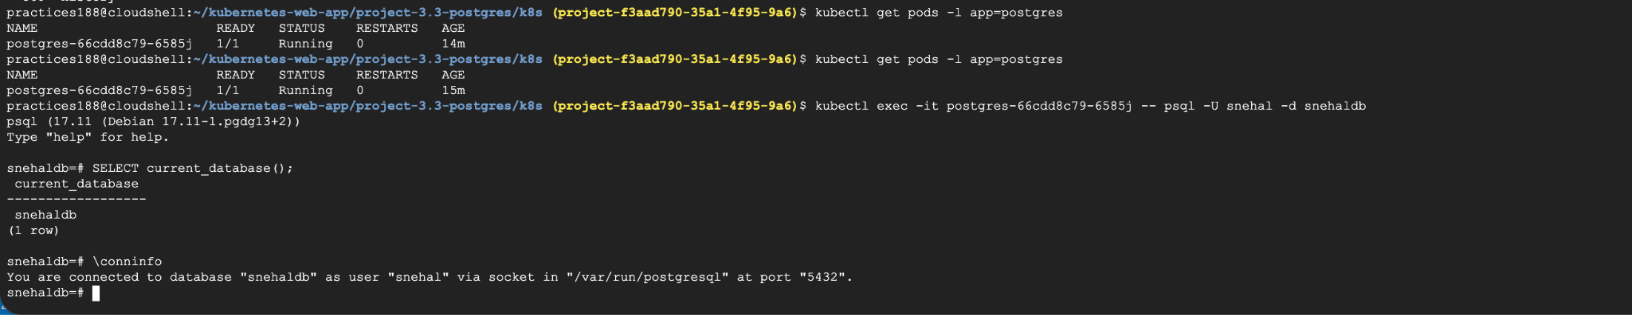

Task 8 - Verify Application Deployment
Confirm that the application is successfully running inside the Kubernetes cluster.
Verify that:
- ﻿﻿Persistent storage works correctly
- ﻿﻿Configuration values are loaded from ConfigMap
- ﻿﻿Sensitive credentials are accessed from Secrets
- ﻿﻿Application is reachable through the Service

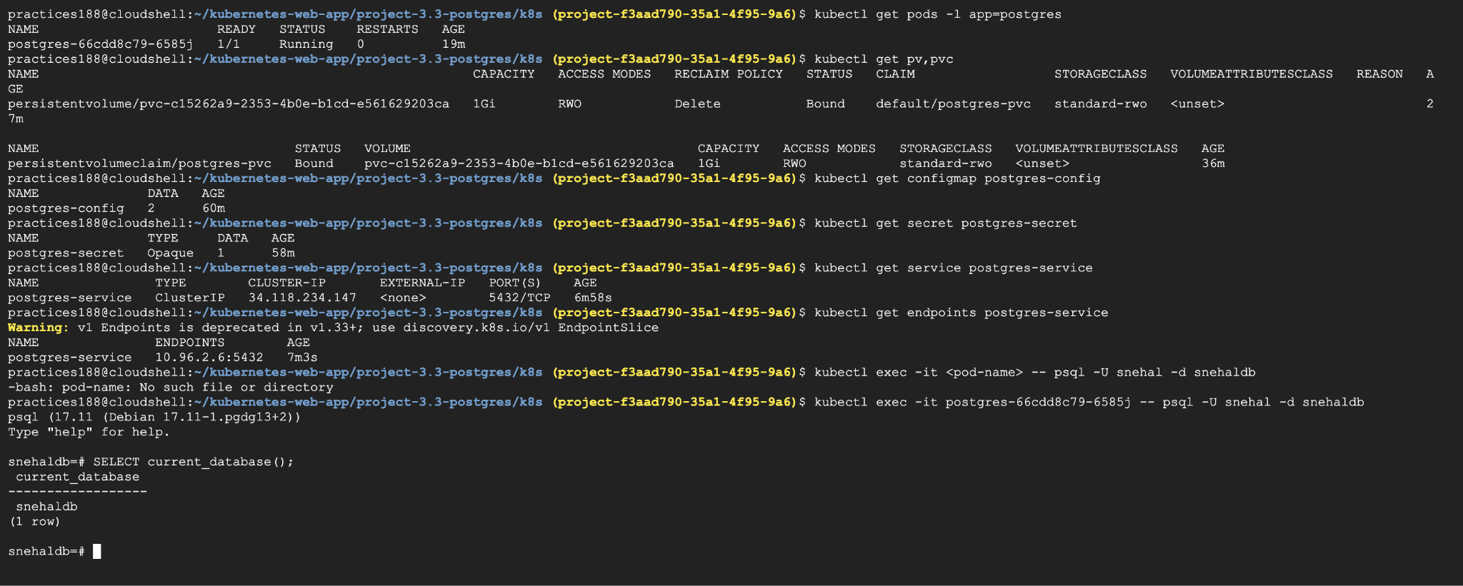

#kubectl get pods -l app=postgres
#kubectl get pv,pvc
#kubectl get configmap postgres-config
#kubectl get secret postgres-secret
#kubectl get service postgres-service
#kubectl get endpoints postgres-service
#kubectl exec -it <pod-name> -- psql -U snehal -d snehaldb
#kubectl exec -it postgres-66cdd8c79-6585j -- psql -U snehal -d snehaldb

Test Persistent Storage:
kubectl exec -it postgres-66cdd8c79-6585j -- psql -U snehal -d snehaldb
-Create a table
CREATE TABLE employees (
id SERIAL PRIMARY KEY,
name VARCHAR(100),
role VARCHAR(100)
);

Insert some data
INSERT INTO employees (name, role) VALUES ('Snehal', 'DevOps Engineer');

Retrieve the data:SELECT * FROM employees;

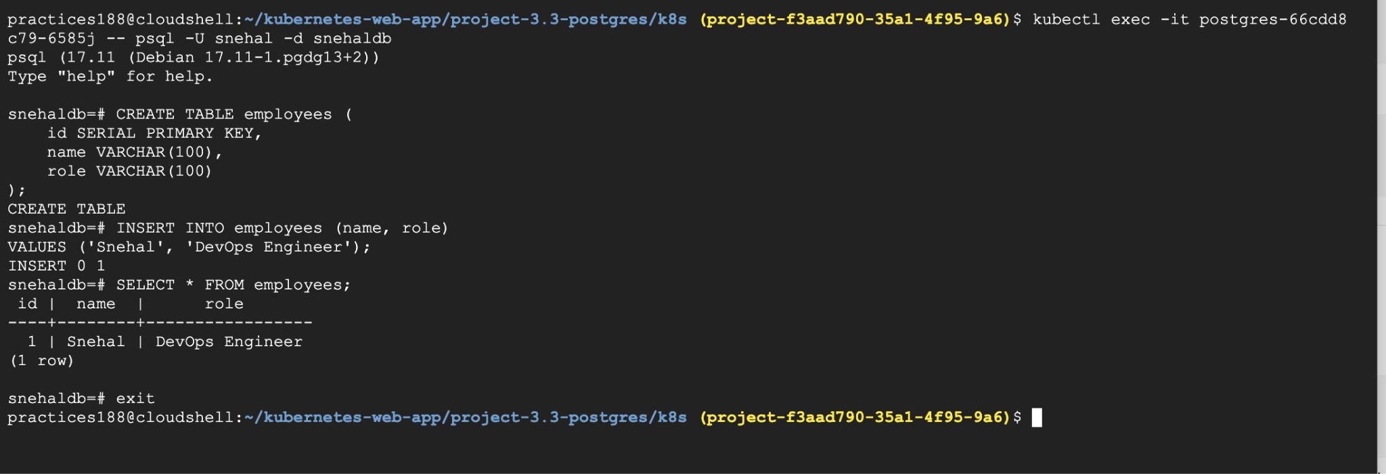
Now we'll perform the actual persistence test.
First, check the current Pod:kubectl get pods -l app=postgres
Then delete it:kubectl delete pod postgres-66cdd8c79-6585j

Because the Pod is managed by a Deployment, Kubernetes should automatically create a replacement Pod.
kubectl get pods -l app=postgres -w

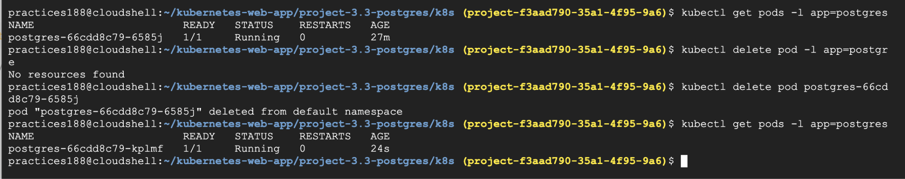

Verify the data survived
#kubectl exec -it postgres-66cdd8c79-kplmf -- psql -U snehal -d snehaldb
#Once connected : run:
SELECT * FROM employees;

